**Diesel Engine Troubleshoot program**

**Objective** To write a program that troubleshoots a diesel engine.

**Description**

Program takes inputs from user for the diesel engine status lights –

1. Red
2. Amber
3. Green

The user can enter the serial number or the color itself. The program is designed to work for both type of inputs.

If the user enters “Red”, further inputs are taken to check meter rating, main line pressure and flow velocity. Based on the inputs, the user is instructed to refer to appropriate manuals.

If the user enters “Amber”, the user is instructed to check the fuel line service routine.

If the user enters “Green”, the user is instructed to restart procedure.

The program is designed to handle negative scenarios –

1. User enters a negative input for meter rating
2. User enters a value apart from the given options

Flowchart for troubleshooting diesel engine:

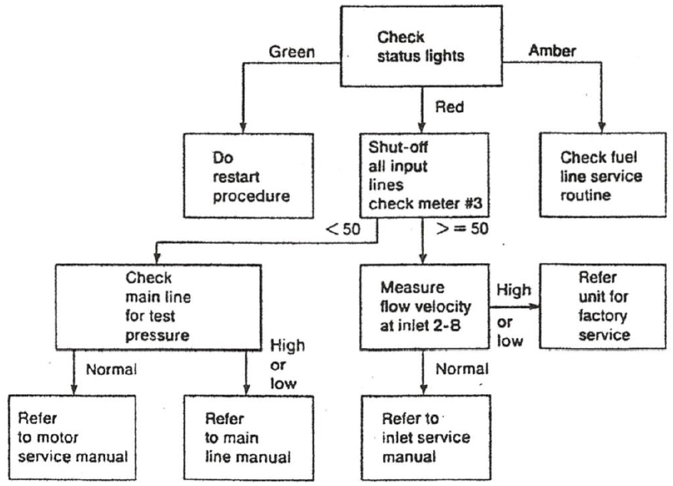

**Snapshots of Testcases:**

1. Scenario 1: User needs to refer to motor service manual

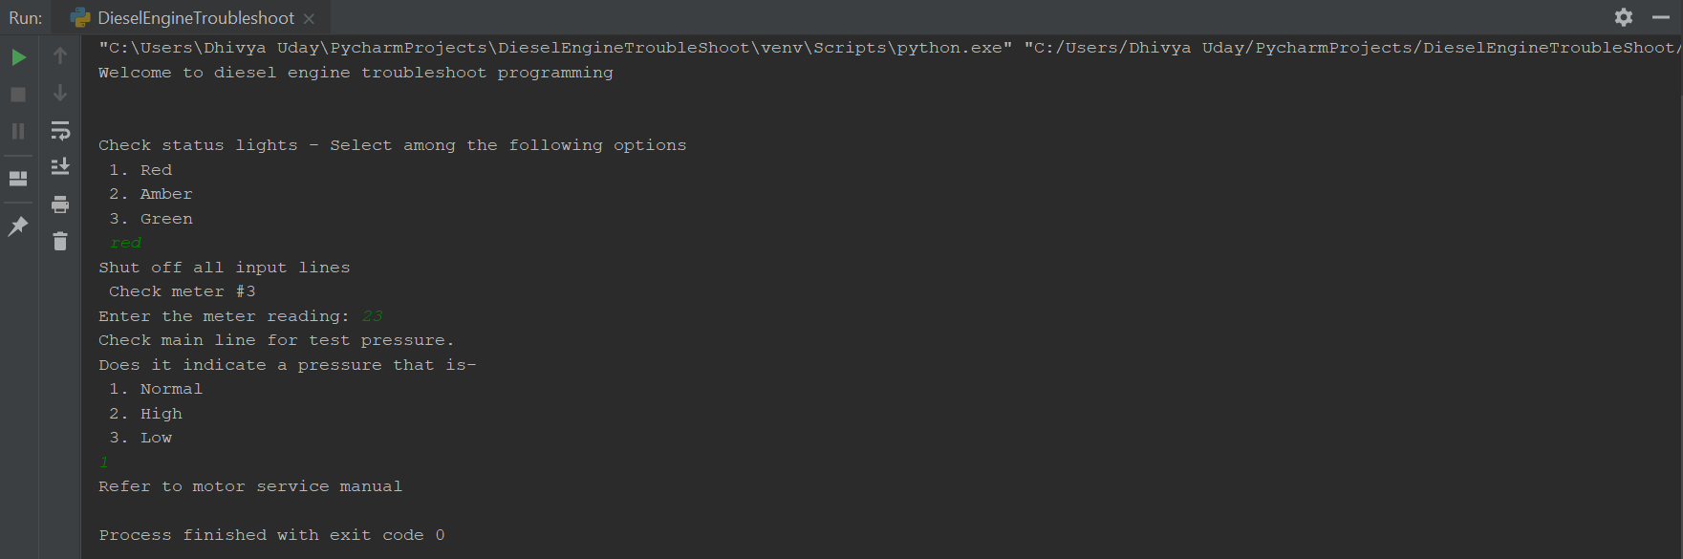

1. Scenario 2: User needs to refer to main line manual

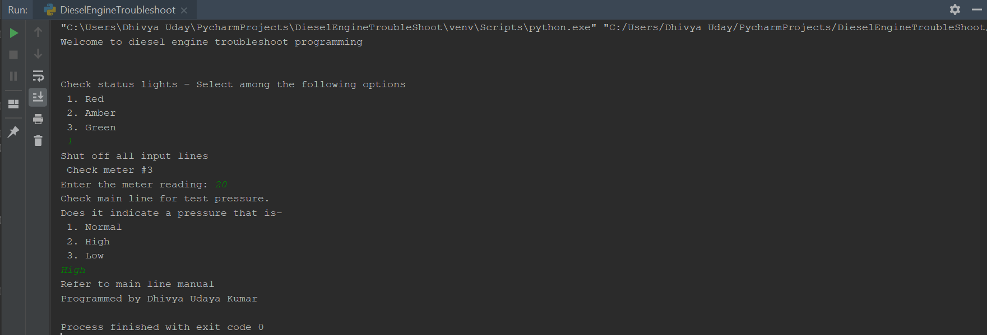

1. Scenario 3: User needs to refer to inlet-service manual

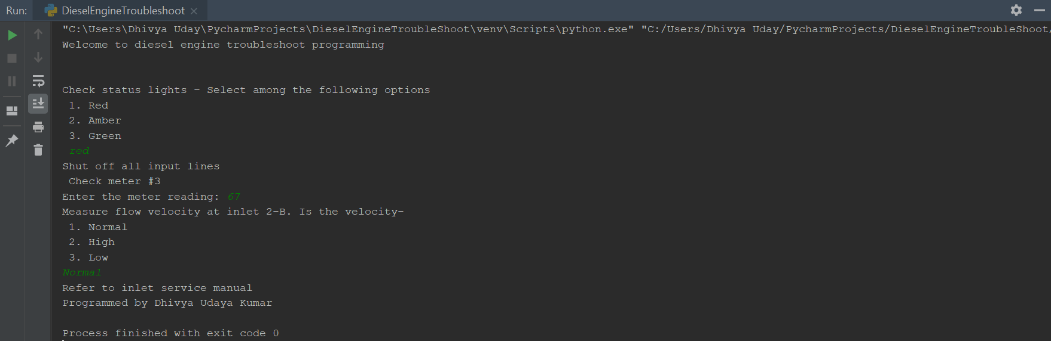

1. Scenario 4: User needs to refer unit for factory service

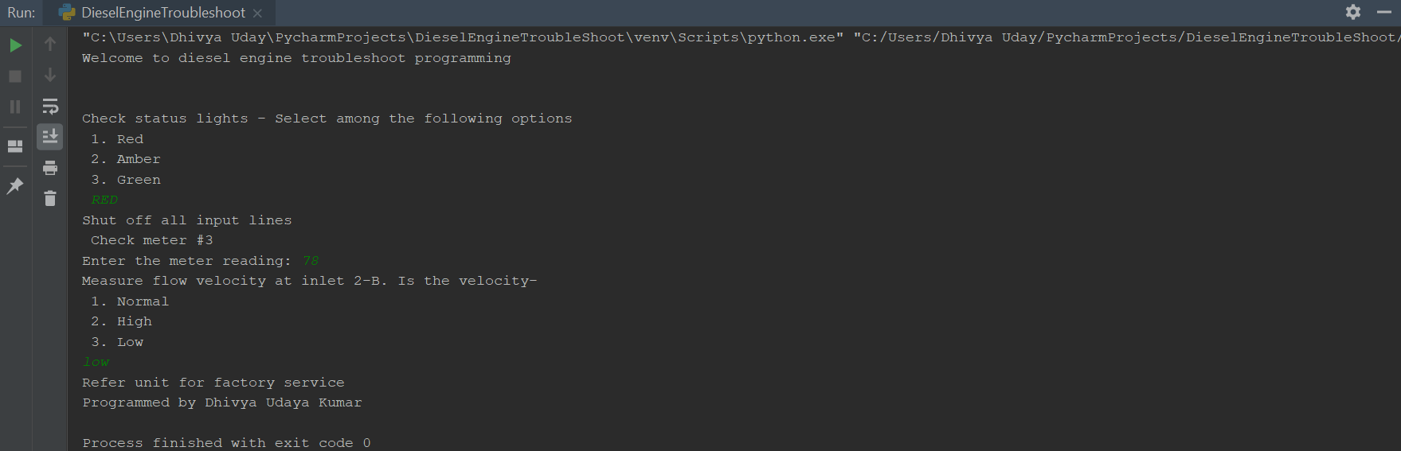

1. Scenario 5: User needs to restart procedure

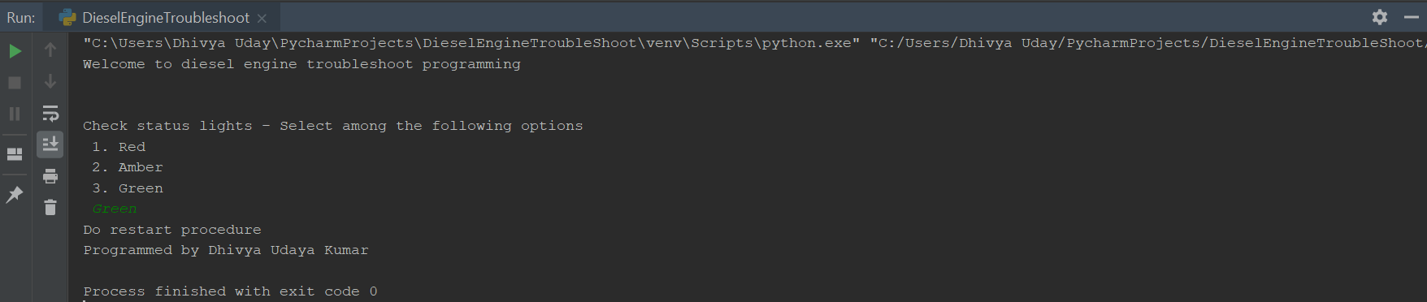

1. Scenario 6: User needs to check fuel line service routine

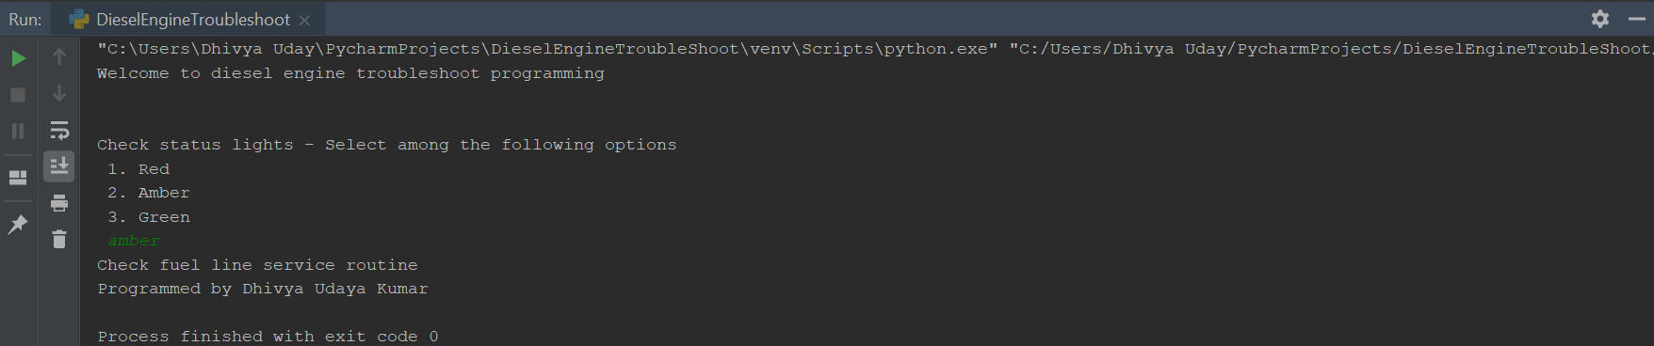

1. Negative scenario 1: User enters invalid input

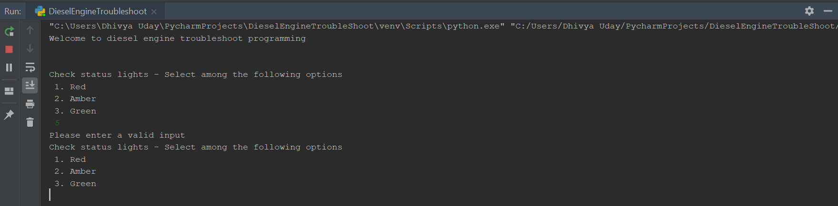

1. Negative scenario 2: User enters a negative value for meter rating

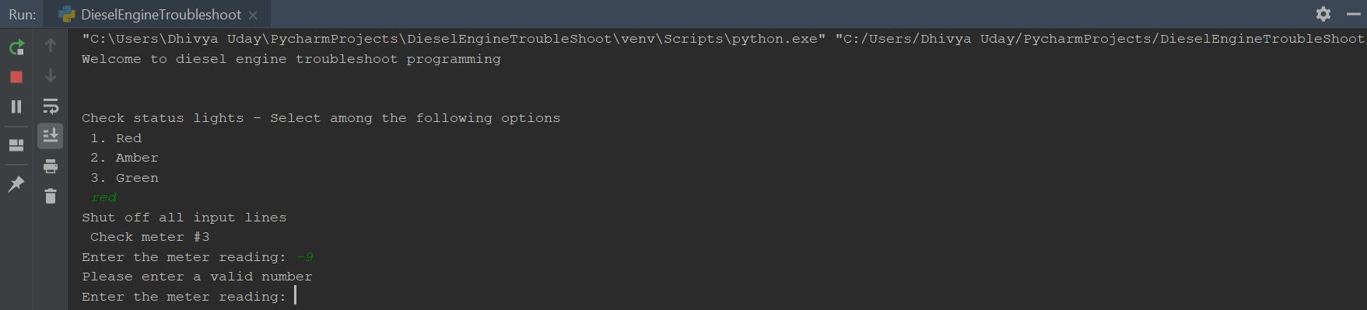

**Source code:**

#Program to troubleshoot diesel engine  
#Programmed by Dhivya Udaya Kumar  
  
print("Welcome to diesel engine troubleshoot programming")  
print("\n")  
  
while True:  
 #Check for status lights  
 lightColor = input("Check status lights - Select among the following options \n 1. Red \n 2. Amber \n 3. Green \n ")  
  
 #Logic for "Red" status  
 if lightColor == "1" or lightColor.lower() == "red":  
 print("Shut off all input lines \n Check meter #3")  
 while True:  
 try:  
 meterReading = int(input("Enter the meter reading: "))  
 assert(meterReading > 0), 'Number must be greater than 0'  
 break  
 except:  
 print("Please enter a valid number")  
  
 #Meter reading check  
 if meterReading < 50:  
 print("Check main line for test pressure.")  
 while True:  
 pressure = input("Does it indicate a pressure that is- \n 1. Normal \n 2. High \n 3. Low \n")  
 #Pressure-check  
 if pressure == "1" or pressure == "2" or pressure == "3" or pressure.lower() == "high" or pressure.lower() == "low" or pressure.lower() == "normal":  
 break  
 else:  
 print("Please enter a valid input")  
  
 if pressure == "1" or pressure.lower() == "normal":  
 print("Refer to motor service manual")  
 elif pressure == "2" or pressure == "3" or pressure.lower() == "high" or pressure.lower() == "low":  
 print("Refer to main line manual")  
  
 else:  
 while True:  
 #Velocity check  
 velocity = input("Measure flow velocity at inlet 2-B. Is the velocity- \n 1. Normal \n 2. High \n 3. Low \n")  
 if velocity == "1" or velocity == "2" or velocity == "3" or velocity.lower() == "normal" or velocity.lower() == "high" or velocity.lower() == "low":  
 break  
 else:  
 print("Please enter a valid input")  
  
 if velocity == "1" or velocity.lower() == "normal":  
 print("Refer to inlet service manual")  
 else:  
 print("Refer unit for factory service")  
 break  
   
 #Logic for "Amber" status  
 elif lightColor == "2" or lightColor.lower() == "amber":  
 print("Check fuel line service routine")  
 break  
  
 #Logic for "Green" status  
 elif lightColor == "3" or lightColor.lower() == "green":  
 print("Do restart procedure")  
 break  
 else:  
 print("Please enter a valid input")  
  
print("Programmed by Dhivya Udaya Kumar")